CARESTAED

Carestead Use Case Submission
Caregiver Cognitive Load Agent
A grounded, approval-aware agent for coordinating changing care responsibilities and evaluating every decision against known outcomes.
Field | Details
Project | GenAI Academy Team Project
Submission | Questions 1 to 3
Prepared | September 2026

Coordination support only. Carestead does not diagnose, prescribe, replace clinical judgment, or replace emergency services.

Submission Overview
Caregiving is not just about completing individual tasks. The harder part is the mental load of coordinating everything around care. Caregivers continuously track changing responsibilities, care information, events, risks, contacts, availability, and follow-ups across multiple people. Even when the information exists, someone still has to remember what needs to happen, notice what changed, know who is responsible, and prevent important work from falling through the cracks.
Carestead is a caregiver cognitive-load agent designed to reduce this coordination burden. It maintains a recipient-specific operational picture, retrieves the records relevant to a question or risk, proposes a constrained next step, requires human approval for consequential changes, and records a scoreable trace of what happened.
The product helps caregivers move from “What am I missing?” to “What needs attention?” to “What should I do next?” while keeping the caregiver in control.

The Three Submission Questions
- Pick the use case: caregiver cognitive-load and care-coordination risk management.
- Knowledge and tools: recipient-scoped structured data, lightweight RAG, constrained application tools, and approved external integrations.
- Autonomy and evaluations: bounded agent autonomy, fixed safety controls, and trajectory-level benchmark scoring.
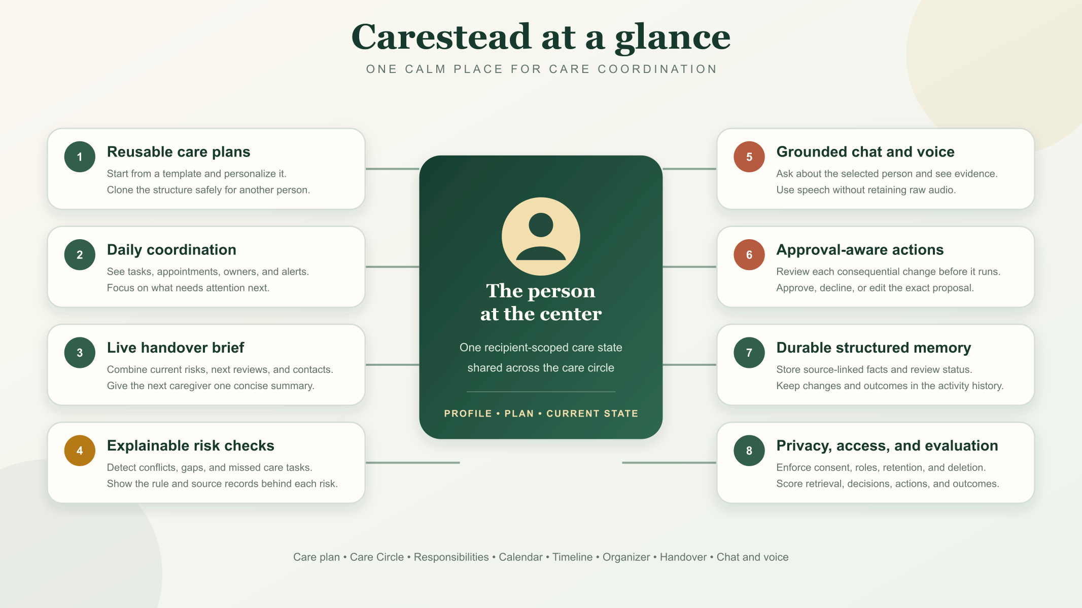
Figure 1 Carestead core product capabilities

Question 1 Pick the Use Case

The Process We Chose
We chose the ongoing coordination of care for an elderly or disabled family member. The painful process is not one isolated task. It is the repeated work of combining responsibilities, calendars, changing care information, caregiver availability, contacts, reminders, approvals, and follow-up evidence into a reliable plan.
The process becomes risky when information is fragmented or stale, two caregivers assume the other person owns a responsibility, an appointment moves without its transportation plan, or an important pickup or follow-up has no confirmed owner. These failures are common coordination problems that an agent can observe and help prevent without acting as a clinical decision-maker.

Why an Agent Fits This Use Case
Carestead is more than a generic assistant because it observes changing recipient state over time, consults multiple sources, makes a constrained decision, proposes or performs an authorized action, and can later be scored against a known outcome. This makes the project useful both as a caregiver product and as an agent-evaluation system.
- Keeps the care plan organized by bringing responsibilities, care information, events, contacts, and updates together for each care recipient.
- Surfaces what needs attention by identifying coordination risks across responsibilities, timeline events, calendars, and trusted information.
- Helps caregivers get answers quickly through recipient-specific chat and voice interactions grounded in stored evidence.
- Suggests the next step and turns an action request into a typed, reviewable proposal.
- Keeps caregivers in control by requiring explicit approval before consequential data or calendar changes.
- Makes handoffs easier through a live summary of current state, priorities, responsibilities, contacts, and support systems.
- Keeps decisions explainable by showing evidence and recording the agent’s decision, policy, tool, and outcome trace.

Core Product Features
Feature | What it provides
Care recipient and profile | Creates an isolated record for each person, including care context, preferences, mobility or access notes, urgent-plan guidance, key contacts, and support systems.
Care plan and templates | Builds a person-specific plan from a reusable, versioned template. Personal overrides are preserved, and a de-identified plan structure can be cloned for another person.
Care Circle | Lets authorized family members, caregivers, and viewers collaborate under recipient-specific roles. Server-side authorization remains the access boundary.
Responsibilities | Creates, assigns, edits, schedules, completes, reopens, verifies, and archives care tasks with an owner, status, due date, and audit history.
Care Organizer | Helps a caregiver plan ahead for a break, activity, outing, respite period, or coverage need by turning the goal into coordinated responsibilities and calendar items.
Calendar scheduling | Shows care events and conflicts and connects to Google Calendar for approved event creation or rescheduling. Calendar writes are constrained and auditable.
Timeline and activity logs | Presents recent and upcoming events, care-state changes, notifications, approvals, agent actions, and outcomes in chronological context.
Handover | Consolidates the profile, latest state, unresolved risks, pending reviews, upcoming responsibilities, Care Circle, contacts, providers, and support systems for the next caregiver.
Ask Carestead chat | Answers questions for the selected recipient, displays the records used as evidence, and converts action requests into pending proposals.
Voice interaction | Accepts speech input and can read responses aloud through browser speech capabilities. Only transcript text is retained; raw microphone audio is not stored.
Risk checks and approvals | Detects coordination risks using testable rules and holds consequential actions for an authorized caregiver to approve or cancel.
Memory and integrations | Stores source-linked trusted facts in Cloudflare D1. The Integrations tab exposes Google Calendar and an optional Mem0 connector; Mem0 is not required for the core MVP.
Notifications | Creates recipient-scoped in-app notices with held, delivered, and read states; approval-linked notifications are not released early.
Authentication and privacy | Provides sign-up, sign-in, and sign-out experiences while enforcing roles, consent, retention, export, deletion, validation, throttling, and privacy-safe monitoring on the server.
Evaluation and audit | Records evidence, decisions, policy checks, tool calls, and outcomes and compares them with a 16-scenario synthetic benchmark.

Question 2 Knowledge and Tools

What the Agent Needs to Know
Carestead evaluates a recipient’s current care state rather than relying on a long conversation transcript. The following records provide that state:
- Responsibilities. What needs to be done, who owns it, deadlines, dependencies, and completion status.
- Timeline and calendar events. Recent and upcoming care-related events, changes, conflicts, and external calendar references.
- Trusted facts. Source-linked information with confidence, verification status, and review or expiry dates.
- Risks and approvals. Detected coordination issues, proposed actions, policy results, and items waiting for review.
- Recipient profile and care plan. The person’s current context, preferences, plan template, personal overrides, and urgent-plan guidance.
- Care Circle and support contacts. Authorized caregivers, family members, providers, backup contacts, services, and roles.
- Care Organizer context. The caregiver’s planned break or activity, coverage window, constraints, and related responsibilities.
- Consent and integration state. Whether data processing is active and which external services are connected and authorized.

What the Agent Needs to Do
- Retrieve the information relevant to the current question, signal, or requested action.
- Evaluate that evidence for coordination risks, conflicts, missing ownership, and stale information.
- Determine whether the evidence is sufficient and ask for clarification when it is not.
- Provide a grounded answer and show the supporting records.
- Propose an appropriate next action, including organizer, responsibility, calendar, notification, or care-check actions.
- Route consequential actions through the caregiver approval policy.
- Execute only a narrow, authorized tool and then record its result.
- Write the evidence, decision, policy check, tool use, and outcome to the evaluation trace.

Why One Care State Agent
Carestead uses one care-state agent rather than multiple agents because the MVP has one core job: understand the selected recipient’s care state, identify coordination risks, and determine the appropriate next step. The decision engine is intentionally deterministic, which keeps the system simpler, testable, and auditable without adding unnecessary multi-agent complexity. An LLM adapter can later improve natural-language reasoning while remaining behind the same retrieval, policy, and approval controls.

Where RAG Fits
RAG handles the “look up the right information” part of the agent. Carestead uses lightweight structured retrieval rather than a separate vector database. It retrieves relevant responsibilities, events, trusted facts, profile details, contacts, risks, approvals, plan records, and recent traces directly from Cloudflare D1. Every query is filtered by an authorized recipient_id, so the agent receives context only for the selected person.
This approach is appropriate for the MVP because the important facts are already structured, attributable, and time-sensitive. It also makes evidence recall and recipient isolation straightforward to test. Mem0 may be available through the Integrations tab for experiments with an external memory service, but Carestead’s core memory and RAG path do not depend on it.

Tools and Actions
Tool category | Capability | Control
Responsibility tools | Create, edit, assign, reschedule, complete, reopen, and archive responsibilities. | Approval for consequential chat-proposed writes
Care Organizer tools | Create a break, activity, respite, or coverage plan and propose the supporting responsibilities and schedule. | Caregiver reviews the generated plan
Calendar tools | Read conflicts and create or reschedule approved events through the Google Calendar connector. | Approval and OAuth scope required
Memory tools | Create, edit, verify, review, and archive source-linked trusted facts. | Role, consent, and validation enforced
Care check tool | Run deterministic risk rules across the current recipient state. | Read and evaluate automatically
Notification tools | Create recipient-scoped in-app notifications and release approval-linked notices. | Held until associated approval when required
Profile and handover tools | Update recipient context and contacts and assemble a live handover brief. | Restricted by recipient role
Privacy tools | Change consent, export recipient data, apply retention, and permanently delete a recipient. | Owner-only or explicitly verified controls

Overall Agent Flow
Care state → recipient-scoped RAG → agent evaluation → grounded answer or proposed action → policy and caregiver approval → constrained tool execution → outcome and trace recording.

Solution Architecture
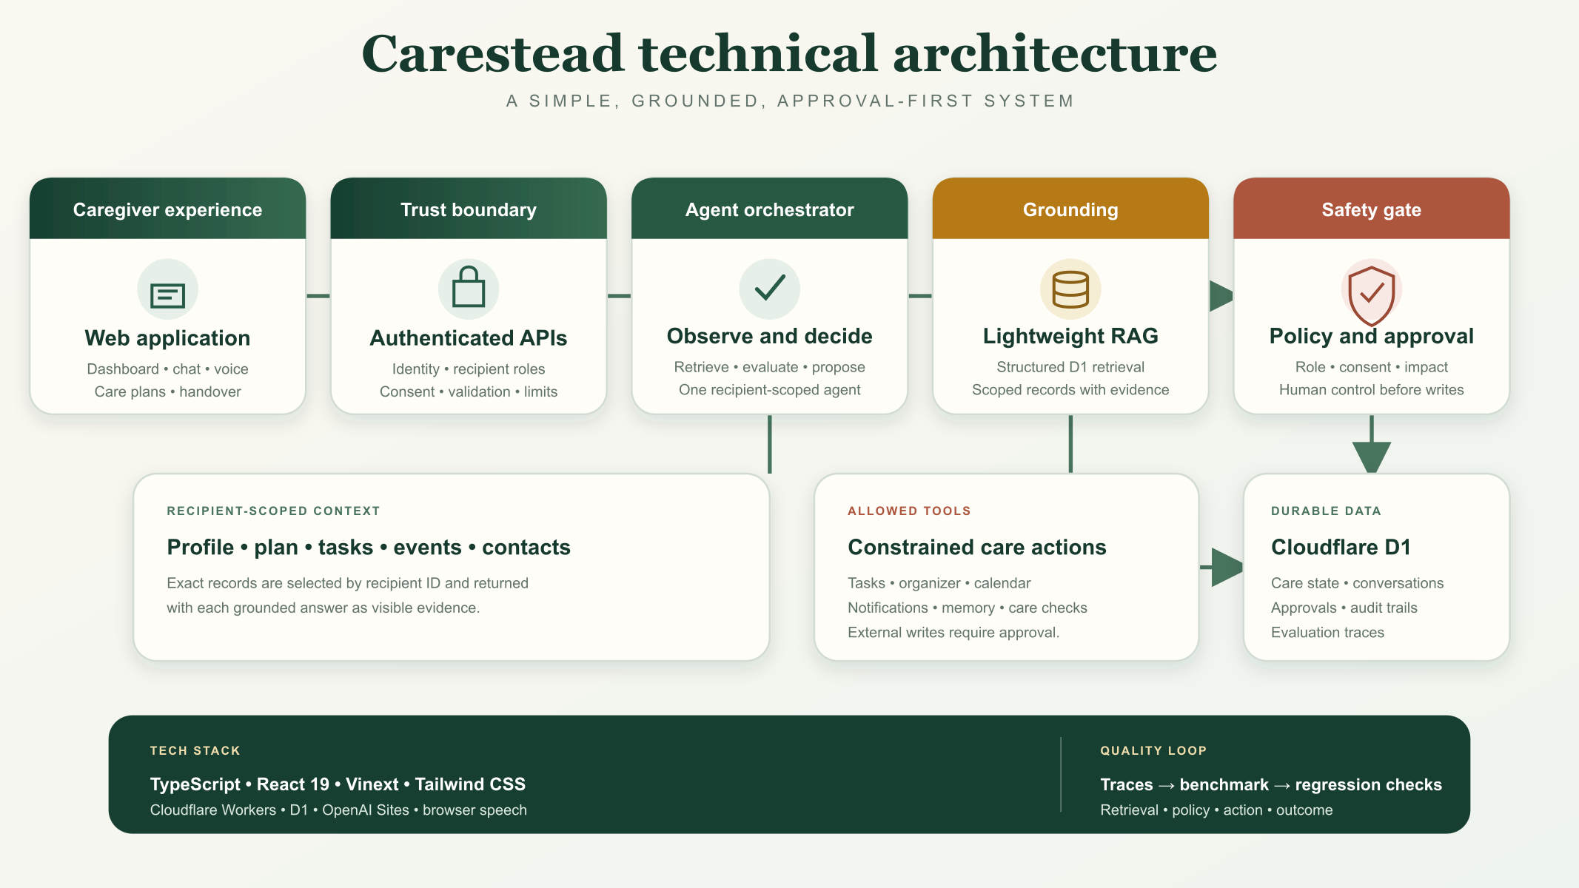
Figure 2 Core technical architecture
The architecture extends this core with three explicit product surfaces. The Authentication experience provides sign-up, sign-in, and sign-out screens while server-side identity and recipient roles remain authoritative. The Care Organizer sends a caregiver goal through the same orchestrator and approval controls before creating tasks or schedule items. The Integrations layer connects Google Calendar through scoped authorization and exposes Mem0 as optional rather than as a core dependency.

Technical Stack
Layer | Technology and design choice
Frontend | TypeScript, React 19, Vinext, and Tailwind CSS
Hosting and APIs | OpenAI Sites and Cloudflare Workers-style server routes
Database and memory | Cloudflare D1 structured relational storage; no Mem0 dependency for the core MVP
Agent layer | Single deterministic care-state orchestrator with a future optional LLM reasoning adapter
RAG | Recipient-scoped structured retrieval from D1; no separate vector database required
Calendar integration | Google Calendar API with scoped OAuth authorization and approval-gated writes
Voice | Browser speech recognition and speech synthesis with text-only transcript retention
Identity and access | Sign-up, sign-in, and sign-out UI plus server-side recipient roles and authorization
Testing and evaluation | Synthetic benchmark runner, Playwright, axe-core, and GitHub Actions

Question 3 Autonomy and Evaluations

How Much the Agent Decides
Carestead uses bounded autonomy. The agent can retrieve relevant information, evaluate coordination risks, identify what needs attention, answer grounded questions, and propose a next action. It does not receive unrestricted database or external-service access.
For the MVP, the decision engine is deterministic and auditable. Consequential actions require an authorized caregiver to explicitly approve or cancel before they execute. Authorization, recipient permissions, consent, validation, retention, tool allow-lists, and approval requirements follow fixed rules rather than being left to the agent.
Decision owner | Responsibility
Agent may decide | Which records are relevant; whether evidence is sufficient; whether a coordination risk exists; the severity and rationale; which safe action to propose; how to summarize the answer.
Fixed controls decide | Who may access the recipient; whether consent is active; whether an action is allowed; whether approval is required; input limits; external integration scopes; retention and deletion rules.
Caregiver decides | Whether to approve consequential actions; whether to connect an integration; whether a proposed plan is practical; whether recipient data should be exported or deleted.
Carestead must never decide | Diagnosis, medication dose changes, whether an interruption is medically safe, or whether emergency care is unnecessary.

Decision and Approval Path
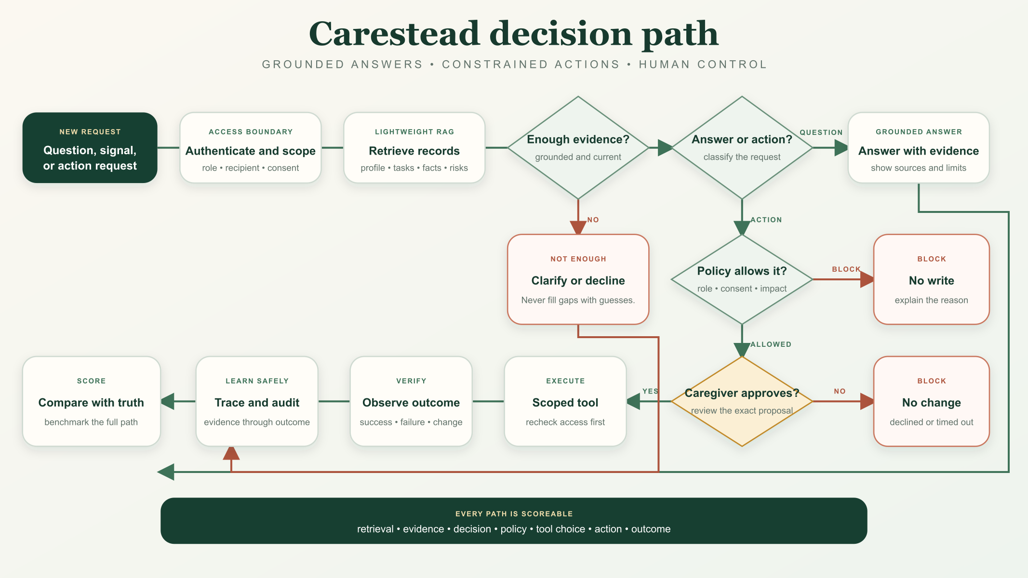
Figure 3 Agent decision and approval path

How We Evaluate It
Carestead uses a synthetic benchmark of 16 curated caregiving scenarios with ground-truth expectations for evidence, severity, approval requirements, and action class. The scenarios cover medication coordination, transportation, appointments, check-ins, household needs, memory quality, and robustness. Hard cases remain visible so failures can drive regression improvement.
The core benchmark evaluates four parts of the agent journey:
- Retrieval. Did the agent find the right evidence and avoid unrelated or cross-recipient records?
- Decision. Did it correctly identify the expected risk, issue, or need for clarification?
- Policy. Did it correctly determine whether the action was allowed and whether approval was required?
- Action. Did it select the expected safe action and allowed tool?
Operational tests also check authentication, recipient isolation, approval gating, consent, retention, deletion, validation, rate limiting, accessibility, and integration failure handling. This tests the complete trajectory rather than only the final wording of an answer.

What a Good Result Looks Like
A good result follows the chain: right evidence → right decision → right policy → right action → verified outcome. For a consequential action, success also means the agent pauses for caregiver approval, executes only the reviewed proposal, reports tool success or failure accurately, and makes the result visible in the timeline and evaluation trace.

How We Catch a Bad Result
Each benchmark scenario has known expected outcomes, so observed behavior can be compared with ground truth. Carestead records a trace containing the trigger, retrieved evidence, decision, policy result, proposed tool, caregiver approval, execution result, and outcome. When a scenario fails, the trace identifies whether the problem came from retrieval, reasoning, policy, tool choice, execution, or follow-up.
- Unsafe medical recommendations, invented facts, cross-recipient leakage, or unauthorized writes are safety failures.
- Missing a known risk, using stale evidence, choosing the wrong severity, or proposing an irrelevant action is a quality failure.
- Executing before approval, exceeding an OAuth scope, or releasing a held notification is a policy failure.
- Claiming success when a calendar or application tool failed is an outcome-verification failure.
- Repeated low-value reminders are tracked as notification burden and caregiver interruption cost.

Evaluation Strategy Summary
Evaluation dimension | Good result
Evidence quality | Expected source records are retrieved; unrelated and cross-recipient records are excluded.
Decision quality | The expected coordination issue, severity, and evidence sufficiency decision are correct.
Policy compliance | Role, consent, approval, and prohibited-action rules are applied without exception.
Tool selection | The chosen responsibility, organizer, calendar, memory, notification, or care-check action matches the scenario.
Outcome quality | Execution is verified, failures are reported honestly, and the resulting state matches the expected outcome.
Robustness | Stale, duplicate, contradictory, or incomplete records lead to clarification or safe handling rather than confident invention.

Conclusion
Carestead addresses a real and measurable coordination burden. It combines a recipient-centered care plan, Care Circle collaboration, responsibilities, Care Organizer planning, calendars, activity history, handover, grounded chat and voice, optional integrations, and approval-aware actions in one system. Its architecture keeps structured data and fixed policy controls authoritative while giving the agent enough flexibility to retrieve evidence, detect risks, explain its reasoning, and propose useful next steps.
The result is an agent that can be evaluated at every stage, from retrieval through outcome, while remaining a non-clinical care-coordination aid with meaningful human control.

